

Faculty of Applied Science and Technology

Lab #4 – Write Simple Script Files
Michaël McCorkell
Maryam Davoudpour
October 15th, 2025
Procedures and results:
1.
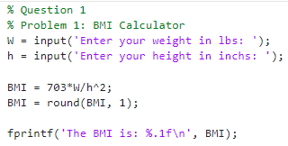
1.1)
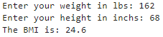

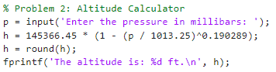
1.2)
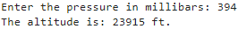

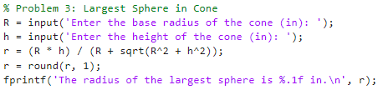
1.3)

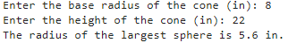

1.4)
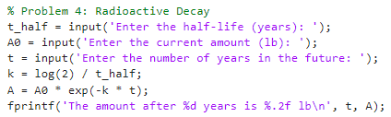

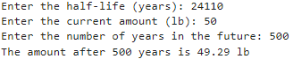

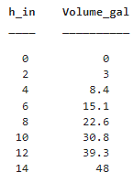
1.5)
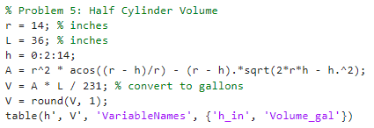

1.6)

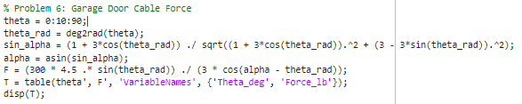

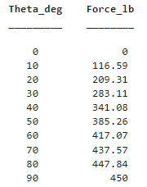

2)
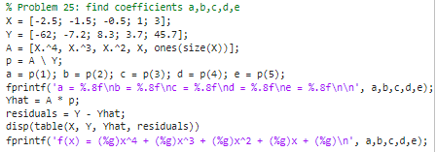
2.1)

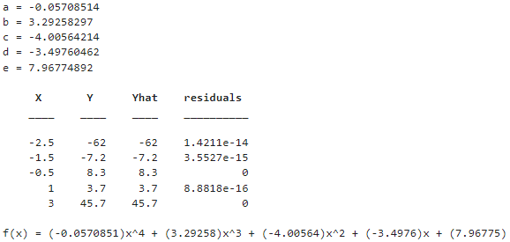

2.2)
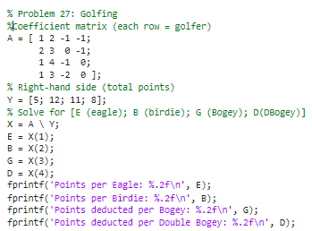

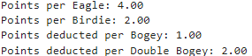

Tracing Exercise:
Let # be spaces for Answers
P: 0 4 8 12 16 20  Q: 100 200 300 400 500 600  r: 100 204 308 412 516 620  fprintf ('%5.2f\n%5d\n8.3%d\n', p(3), q(4), r(5), q(2)); | #8.00  ##400  8.3516  200
n1 = 5.45679  n2= 16.5673  n3 = 66  n4 = -87.355657  fprintf ('%8.5f\n', n4);  fprintf ('%4.4f\n', n4);  fprintf ('%8.5f\n', n1);  fprintf ('%-12d\n', n3);  fprintf ('$B%5.0fS\n', n4);  fprintf ('%7.7f\n', n2);  fprintf ('%3.2f\n%2.2f', n2,n4);  fprintf ('%8.4f\n', n1+n3); | -87.35565  -87.3556  #5.45679  66  $B##-87S  16.56300  16.57  -87.36#71.4568

